**Follow the Simple Path of Nirvana to DevOps**

[contributor](http://devops.com/author/contributor/)BY [CONTRIBUTOR](http://devops.com/author/contributor/) ON JULY 13, 2016 [0 COMMENTS](http://devops.com/2016/07/13/follow-simple-path-nirvana-devops/#disqus_thread)



Perhaps the title of this post is a misleading, as nothing is truly “simple. But there is a well-defined pathway to achieving DevOps goals for any size company. Just follow a step-up pattern by adopting the principles of agile, continuous integration and continuous delivery, and you will reach your goal of DevOps. This path is a natural progression of DevOps maturity that an organization can follow while adopting key principles and technology solutions along the way.

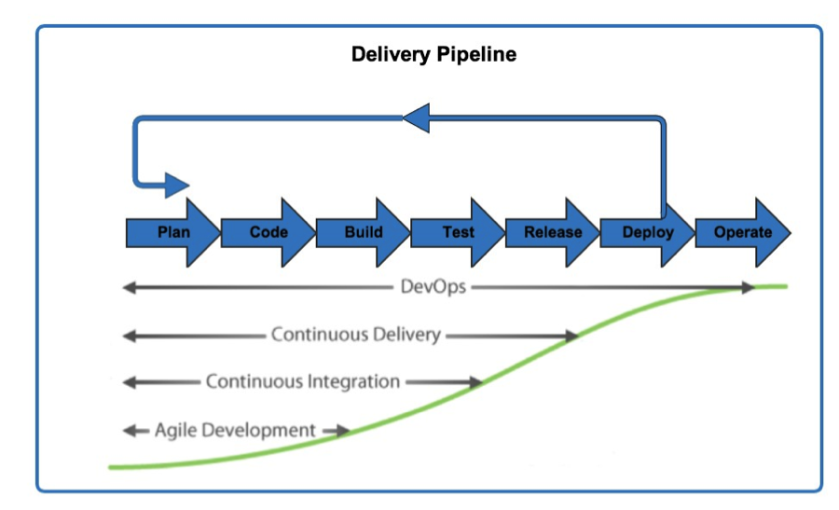

Agile Development

Adopting agile development methodologies often is the first step maturing organizations take, as they no doubt have heard the resounding benefits of leaving behind waterfall software development life cycles. There is a reason this is the first step. It helps your organization’s employees mature into a tightly knit working machine that fosters improvements in driving down technical debt while also laser-focused on building key features.

As agile teams continue their maturation, they’ve roped in key business stakeholders who are able to grasp the drivers of technology challenges and are able balance out the growth needs of the business with the sustainability requirements of the technology teams. Suddenly, teams are investing a minimum of 20 percent of their sprint time to dealing with technical debt and reporting out these victories to their product owner(s). These small wins become major victories as the unwieldy pieces of infrastructure and software of the business become relics and folklore of yesteryear.

But there is an underlying reason why agile development is the most crucial first step: It truly empowers the developers to improve the customer experience and feel good about it. With the scrum master’s shields up protecting the team from burnout and ensuring sprint planning happens, team members are more likely to be passionate about their work and the results of their efforts to the business and customer. This is where the empowerment of DevOps really begins.

Continuous Integration

As teams mature along the agile development continuum, the next step in their DevOps maturation is moving on to  continuous integration. Continuous integration is the process by which a company automates its software build process: code check-in triggers a build job that then triggers a test validation job and so-on. This process enables teams to continuously integrate their code build with downstream processes, avoiding manual touchpoints.

In addition, this paradigm allows for faster feedback loops to ensure a higher quality product, and empowers diverse teams to work together utilizing automation as the “middle man.”

Continuous Delivery

The third step in DevOps maturation is continuous delivery. Often businesses confuse “delivery” with “deployment”—in fact, continuous delivery is simply the process to ensure that at any given point a company’s software is in a state where it can be deployed. This is useful for quick iterations, A/B testing and a more mature way of delighting customers fast and often.

A key component of continuous delivery is ensuring that software is ready for production. When a team is doing continuous delivery, they’re assured that they’re nimble and responsive and adhere to the highest quality standards.

DevOps

At this point, the company has reached the DevOps nirvana state. This is where software is not just delivered continuously, but all of the operational needs are constantly met. Monitoring, metrics, the ability to automatically roll back software releases, scalability and much more are the key building blocks to a powerful DevOps organization.

With this thoughtful step-by-step process of DevOps adoption, organizations can meet the needs of business in a mindful and cohesive way without compromise.

I’d love to hear any feedback or tips on DevOps at [@jsin](https://twitter.com/jsin).

About the Author/Jason Shawn

Jason Shawn is a technology leader in DevOps and Cloud. His began his career as a software developer and has held multiple functional and managerial roles which has found him with a unique perspective on the software development lifecycle. He’s extremely passionate about Continuous Delivery, Agile software development, and empowering teams to adopt DevOps and Agile principles in their daily lives. He is also a member of the Cloudbees Customer Advisory Board and enjoys public speaking, travel, and time with his family.

FILED UNDER: [BLOGS](http://devops.com/category/blogs/), [DOIN' DEVOPS](http://devops.com/category/blogs/devops-life/)TAGGED WITH: [AGILE DEVELOPMENT](http://devops.com/tag/agile-development/), [CODE](http://devops.com/tag/code/), [CONTINUOUS DELIVERY](http://devops.com/tag/continuous-delivery/), [CONTINUOUS INTEGRATION](http://devops.com/tag/continuous-integration/), [DEVELOPERS](http://devops.com/tag/developers/), [DEVOPS](http://devops.com/tag/devops/), [SOFTWARE DELIVERY](http://devops.com/tag/software-delivery/), [SOFTWARE DEVELOPMENT](http://devops.com/tag/software-development/)

* [108Click to share on LinkedIn (Opens in new window)108](http://devops.com/2016/07/13/follow-simple-path-nirvana-devops/?share=linkedin&nb=1)
* [Click to share on Twitter (Opens in new window)](http://devops.com/2016/07/13/follow-simple-path-nirvana-devops/?share=twitter&nb=1)
* [53Click to share on Facebook (Opens in new window)53](http://devops.com/2016/07/13/follow-simple-path-nirvana-devops/?share=facebook&nb=1)
* [Click to share on Reddit (Opens in new window)](http://devops.com/2016/07/13/follow-simple-path-nirvana-devops/?share=reddit&nb=1)
* [Click to share on Google+ (Opens in new window)](http://devops.com/2016/07/13/follow-simple-path-nirvana-devops/?share=google-plus-1&nb=1)
* [More](http://devops.com/2016/07/13/follow-simple-path-nirvana-devops/)